
Web Service Implementation Methodology – Rational Unified Process (Example)
Working Draft 02, 23 December 2004
Document identifier:
0000.doc
Location:
http://www.oasis-open.org/committees/documents.php?wg_abbrev=fwsi
Editors:
Lai Peng CHAN, Singapore Institute of Manufacturing Technology
<lpchan@SIMTech.a-star.edu.sg>
Chai Hong ANG, Singapore Institute of Manufacturing Technology
<chang@SIMTech.a-star.edu.sg>

Contributors:
Eng Wah LEE, Singapore Institute of Manufacturing Technology
<ewlee@SIMTech.a-star.edu.sg>
Puay Siew TAN, Singapore Institute of Manufacturing Technology
<pstan@SIMTech.a-star.edu.sg>
Yushi CHENG, Singapore Institute of Manufacturing Technology
<ycheng@SIMTech.a-star.edu.sg>
Xingjian XU, Singapore Institute of Manufacturing Technology
<xjxu@SIMTech.a-star.edu.sg>
Zun Liang YIN, Singapore Institute of Manufacturing Technology
<zlyin@SIMTech.a-star.edu.sg>
Andy TAN, individual, <andytan@intrinix.net>
Roberto PASCUAL, The Infocomm Development Authority of Singapore <Roberto_B_Pascual@ida.gov.sg>
JAGDIP Talla, CrimsonLogic Pte Ltd <jagdip@crimsonlogic.com>
RAVI SHANKAR Narayanan Nair, CrimsonLogic Pte Ltd <ravishankar@crimsonlogic.com>
Marc HAINES, individual <mhaines@uwm.edu>

Abstract:
This document specifies Web service specific activities in a Web service implementation methodology and illustrates the approach to incorporate these activities into an existing agile software development methodology.
Status:
This document is updated periodically on no particular schedule. Send comments to the editor.
Committee members should send comments on this specification to the fwsi-imsc@lists.oasis-open.org list. Others should subscribe to and send comments to the fwsi-comment@lists.oasis-open.org list. To subscribe, send an email message to fwsi-comment-request@lists.oasis-open.org with the word "subscribe" as the body of the message.
For information on whether any patents have been disclosed that may be essential to implementing this specification, and any offers of patent licensing terms, please refer to the Intellectual Property Rights section of the FWSI TC web page (http://www.oasis-open.org/committees/fwsi/).
Table of Contents
1 Case Example(s) of Applying the Implementation Methodology 9
1.1 Rational Unified Process (Example) 9
1.1.1 Overview 9
1.1.2 Approach 11
1.1.2.1 Discipline: Requirements 12
1.1.2.1.1 Workflow Detail: Analyze the Problem 12
1.1.2.1.1.1 Activity: Capture a Common Vocabulary 12
1.1.2.1.1.1.1 Role 12
1.1.2.1.1.1.2 Artifact 13
1.1.2.1.1.2 Activity: Develop Vision (across all Web services) 13
1.1.2.1.1.2.1 Role 13
1.1.2.1.1.2.2 Artifact 13
1.1.2.1.2 Workflow Detail: Understand Stakeholder Needs 13
1.1.2.1.2.1 Activity: Elicit Needs 13
1.1.2.1.2.1.1 Role 13
1.1.2.1.2.1.2 Artifact 13
1.1.2.1.2.2 Activity: Develop Vision 13
1.1.2.1.2.2.1 Role 13
1.1.2.1.2.2.2 Artifact 13
1.1.2.1.2.3 Activity: Manage Dependencies 13
1.1.2.1.2.3.1 Role 14
1.1.2.1.2.3.2 Artifact 14
1.1.2.1.2.4 Activity: Find Actors and Use Cases (per Web service) 14
1.1.2.1.2.4.1 Role 14
1.1.2.1.2.4.2 Artifact 14
1.1.2.1.3 Workflow Detail: Define the System 14
1.1.2.1.3.1 Activity: Find Actors and Use Cases (per Web service) 14
1.1.2.1.3.1.1 Role 14
1.1.2.1.3.1.2 Artifact 14
1.1.2.1.4 Workflow Detail: Manage the Scope of the System 14
1.1.2.1.4.1 Activity: Prioritise the Use Cases (per Web service) 14
1.1.2.1.4.1.1 Role 14
1.1.2.1.4.1.2 Artifact 14
1.1.2.1.5 Workflow Detail: Refine the System Definition 15
1.1.2.1.5.1 Activity: Detail a Use Case 15
1.1.2.1.5.1.1 Role 15
1.1.2.1.5.1.2 Artifact 15
1.1.2.1.5.2 Activity: Detail the Software Requirements 15
1.1.2.1.5.2.1 Role 15
1.1.2.1.5.2.2 Artifact 15
1.1.2.2 Discipline: Analysis and Design 16
1.1.2.2.1 Workflow Detail: Define a Candidate Architecture (for each Web service) 16
1.1.2.2.1.1 Activity: Architectural Analysis 16
1.1.2.2.1.1.1 Role 16
1.1.2.2.1.1.2 Artifact 16
1.1.2.2.2 Workflow Detail: Analyse Behaviour (for each use case) 16
1.1.2.2.2.1 Activity: Use Case Analysis 16
1.1.2.2.2.1.1 Role 17
1.1.2.2.2.1.2 Artifact 17
1.1.2.2.3 Workflow Detail: Refine the Architecture (for each Web service) 17
1.1.2.2.3.1 Activity: Identify Design Elements 17
1.1.2.2.3.1.1 Role 17
1.1.2.2.3.1.2 Artifact 17
1.1.2.2.3.2 Activity: Identify Design Mechanisms 17
1.1.2.2.3.2.1 Role 17
1.1.2.2.3.2.2 Artifact 17
1.1.2.2.4 Workflow Detail: Design Components 17
1.1.2.2.4.1 Activity: Use Case Design 17
1.1.2.2.4.1.1 Role 18
1.1.2.2.4.1.2 Artifact 18
1.1.2.2.4.2 Activity: Subsystem Design 18
1.1.2.2.4.2.1 Role 18
1.1.2.2.4.2.2 Artifact 18
1.1.2.2.4.3 Activity: Class Design 18
1.1.2.2.4.3.1 Role 18
1.1.2.2.4.3.2 Artifact 18
1.1.2.3 Discipline: Implementation 19
1.1.2.3.1 Workflow Detail: Structure the Implementation Model 19
1.1.2.3.1.1 Activity: Structure the Implementation Model 19
1.1.2.3.1.1.1 Role 19
1.1.2.3.1.1.2 Artifact 19
1.1.2.3.2 Workflow Detail: Implement Components 19
1.1.2.3.2.1 Activity: Implement Design Elements 19
1.1.2.3.2.1.1 Role 20
1.1.2.3.2.1.2 Artifact 20
1.1.2.3.3 Workflow Detail: Integrate Each Web Service 20
1.1.2.3.3.1 Activity: Integrate Subsystem 20
1.1.2.3.3.1.1 Role 20
1.1.2.3.3.1.2 Artifact 20
1.1.2.3.4 Workflow Detail: Manage the Scope of the System 20
1.1.2.3.4.1 Activity: Prioritise the Use Cases (per Web service) 20
1.1.2.3.4.1.1 Role 20
1.1.2.3.4.1.2 Artifact 20
1.1.2.3.5 Workflow Detail: Refine the System Definition 20
1.1.2.3.5.1 Activity: Detail a Use Case 20
1.1.2.3.5.1.1 Role 20
1.1.2.3.5.1.2 Artifact 20
1.1.2.3.5.2 Activity: Detail the Software Requirements 21
1.1.2.3.5.2.1 Role 21
1.1.2.3.5.2.2 Artifact 21
1.1.2.4 Discipline: Testing 22
1.1.2.4.1 Workflow Detail: Define Mission 22
1.1.2.4.1.1 Activity: Identify Test Motivators 22
1.1.2.4.1.1.1 Role 23
1.1.2.4.1.1.2 Artifact 23
1.1.2.4.1.2 Activity: Agree on the Mission 23
1.1.2.4.1.2.1 Role 24
1.1.2.4.1.2.2 Artifact 24
1.1.2.4.1.3 Activity: Define Assessment and Traceability Needs 24
1.1.2.4.1.3.1 Role 24
1.1.2.4.1.3.2 Artifact 24
1.1.2.4.1.4 Activity: Define Test Approach 25
1.1.2.4.1.4.1 Role 25
1.1.2.4.1.4.2 Artifact 25
1.1.2.4.1.5 Activity: Identify Test Ideas 25
1.1.2.4.1.5.1 Role 26
1.1.2.4.1.5.2 Artifact 26
1.1.2.4.2 Workflow Detail: Define Test Bed 26
1.1.2.4.2.1 Activity: Identify Test Environment 26
1.1.2.4.2.1.1 Role 26
1.1.2.4.2.1.2 Artifact 26
1.1.2.4.2.2 Activity: Prepare H/W & S/W Infrastructure 26
1.1.2.4.2.2.1 Role 27
1.1.2.4.2.2.2 Artifact 27
1.1.2.4.2.3 Activity: Prepare Test Data Sets 27
1.1.2.4.2.3.1 Role 27
1.1.2.4.2.3.2 Artifact 27
1.1.2.4.3 Workflow Detail: Develop, Test and Evaluate 27
1.1.2.4.3.1 Activity: Define Test Details 27
1.1.2.4.3.1.1 Role 27
1.1.2.4.3.1.2 Artifact 27
1.1.2.4.3.2 Activity: Implement Test 28
1.1.2.4.3.2.1 Role 28
1.1.2.4.3.2.2 Artifact 28
1.1.2.4.3.3 Activity: Implement Test Suite 28
1.1.2.4.3.3.1 Role 28
1.1.2.4.3.3.2 Artifact 28
1.1.2.4.3.4 Activity: Execute Test Suite 28
1.1.2.4.3.4.1 Role 29
1.1.2.4.3.4.2 Artifact 29
1.1.2.4.3.5 Activity: Analyse Test Failures 29
1.1.2.4.3.5.1 Role 29
1.1.2.4.3.5.2 Artifact 29
1.1.2.4.3.6 Activity: Determine Test Results 29
1.1.2.4.3.6.1 Role 29
1.1.2.4.3.6.2 Artifact 29
1.1.2.4.4 Workflow Detail: Improve Test Assets 29
1.1.2.4.4.1 Activity: Define Test Approach (Refinement) 29
1.1.2.4.4.1.1 Role 30
1.1.2.4.4.1.2 Artifact 30
1.1.2.4.4.2 Activity: Identify Test Ideas (Refinement) 30
1.1.2.4.4.2.1 Role 30
1.1.2.4.4.2.2 Artifact 30
1.1.2.4.4.3 Activity: Prepare Guidelines for the Project 30
1.1.2.4.4.3.1 Role 30
1.1.2.4.4.3.2 Artifact 30
1.1.2.5 Discipline: Deployment 31
1.1.2.5.1 Workflow Detail: Plan Deployment 31
1.1.2.5.1.1 Activity: Develop Deployment Plan 31
1.1.2.5.1.1.1 Role 31
1.1.2.5.1.1.2 Artifact 31
1.1.2.5.2 Workflow Detail: Develop Support Material 32
1.1.2.5.2.1 Activity: Develop Training Material 32
1.1.2.5.2.1.1 Role 32
1.1.2.5.2.1.2 Artifact 32
1.1.2.5.2.2 Activity: Develop Support Material 32
1.1.2.5.2.2.1 Role 32
1.1.2.5.2.2.2 Artifact 32
1.1.2.5.3 Workflow Detail: Produce Deployment Unit (Web service) 32
1.1.2.5.3.1 Activity: Write Release Notes 32
1.1.2.5.3.1.1 Role 32
1.1.2.5.3.1.2 Artifact 32
1.1.2.5.3.2 Activity: Develop Installation Artifacts 32
1.1.2.5.3.2.1 Role 32
1.1.2.5.3.2.2 Artifact 32
1.1.2.5.3.3 Activity: Create Deployment Unit (Web service) 33
1.1.2.5.3.3.1 Role 33
1.1.2.5.3.3.2 Artifact 33
1.1.2.5.3.4 Activity: Deploy Web Service to identified app servers 33
1.1.2.5.3.4.1 Role 33
1.1.2.5.3.4.2 Artifact 33
1.1.2.5.3.5 Activity: Publish Web service [optional] 33
1.1.2.5.3.5.1 Role 33
1.1.2.5.3.5.2 Artifact 33
2 References 34
2.1 Normative 34
2.2 Non-Normative 34
Appendix A. Acknowledgments 35
Appendix B. Revision History 36
Appendix C. Notices 37

List of Figures
Figure 3: The Rational Unified Process 13
Figure 4: The RUP development disciplines 15
Figure 5: Requirements Workflow 15
Figure 6: Analysis and Design Workflow 19
Figure 7: Implementation Workflow 22
Figure 8: Testing Workflow 25
Figure 9: Deployment Workflow 34

Case Example(s) of Applying the Implementation Methodology

The case example(s) aims to illustrate how an agile software methodology could be adapted to incorporate the Web services-specific activities described in the previous chapters.

It is not the intention of this Technical Committee to recommend any of the following case example(s) as the recommended agile software methodology to be used for Web services implementation. The Web service implementation methodology is intended to be generic and should be able to incorporate to any agile software methodology.

Rational Unified Process (Example)
In this section, the Rational Unified Process (RUP) is illustrated as an example of how the Web service implementation methodology can be incorporated into RUP. Although the example tries to be as complete as possible, it is foreseeable that different projects set-up may be different in nature and would need to further customise this case example according to their needs.

Overview

The Rational Unified Process® is a software engineering process. It provides a disciplined approach to assigning tasks and responsibilities within a development organization. Its goal is to ensure the production of high quality software that meets the needs of its end users within a predictable schedule and budget.

As illustrated in Source: IBM-Rational Software, the overall architecture of RUP has two dimensions: the horizontal axis represents time and shows the lifecycle aspects of the process as it unfolds. This dimension is expressed in terms of phases, iterations and milestones. The vertical axis represents disciplines that logically group activities by nature. This second dimension portrays the static aspect of the process and is described in terms of process components, disciplines, activities, workflows, artifacts, and roles.

The “humps” in the graph illustrate the relative emphases of the disciplines change over the life of the project. For example, in early iterations more time is spent on Requirements, and in later iterations more time is spent on implementation.

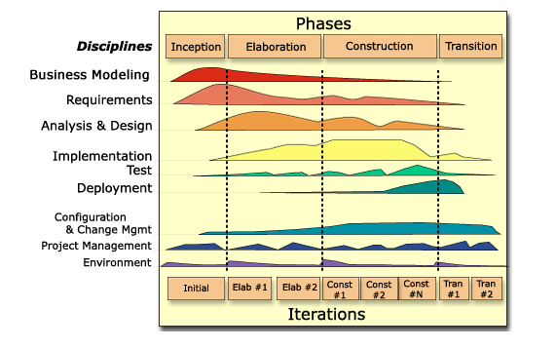
Source: IBM-Rational Software
Figure 1: The Rational Unified Process

As the terms used in RUP are different from the terms used in Web Service Implementation Methodology, Table 1 maps the terms used between the two software methodologies.

RUP |  |  | Web Service Implementation Methodology
Phases |  |  | Lifecycle
Disciplines |  |  | Phases
Roles |  |  | Roles
 | Analyst | System Analysts  Requirements Specifier |  | Analyst | Architect  Requirements Analyst
 | Developer | Software Architect  Designer  Implementer  Integrator |  | Developer | Designer  Developer  Deployer
 | Tester | Test Manager  Test Analyst  Test Designer  Tester  Test System Administrator |  | Tester | Test Manager  Test Designer  Tester  Test System Administrator
 | Production & Support | Deployment Manager  DBA  Process Engineer |  | Others | User  System Engineer  Project Manager  Stakeholder
Artifacts |  |  | Artifacts
 | Glossary  Vision |  |  | Business Requirement Specifications
 | Stakeholder Requests  Requirements Attributes  Requirements Management Plan  Software Requirement  Software Requirements Specifications  Use Case Model  Supplementary Specifications |  |  | Requirement Specifications
 | Software Architecture Document |  |  | Software Architecture Specifications
 | Design Model  Analysis Model  Use Case Realization |  |  | Web Service Signature Specifications  XML Schema  Design Specifications
 | Test Plan  Test Environment Configuration  Test Strategy |  |  | Test Plan – UAT and System Test  Test Plan – Performance Test  Test Plan – Integration / Interoperability Test  Test Plan – Functional Test
 | Test-Ideas List  Test Case  Test Data  Test Suite |  |  | Test Plan – Testbed
 | Test Script |  |  | Test Scripts  Unit Test Scripts  Client Test Code
 | Test Log  Test Results |  |  | Test Results
 | Implementation Model  Implementation Element  Build |  |  | Implementation Codes  Web Service Client Codes
 | Deployment Unit |  |  | Release Notes  Deployment Scripts  WSDL File
 | End-User Support Material |  |  | Interoperability Guide  User Guide  On-line Help  Tutorials
 | Training Materials |  |  | Training Materials
 | Change Request |  |  | Not Applicable
 | Deployment Plan |  |  | Not Applicable
 | Installation Artifacts |  |  | Not Applicable
 | Project Specific Guidelines |  |  | Not Applicable
 | Release Notes |  |  | Not Applicable
 | Test Environment Summary |  |  | Not Applicable
Table 1: Mapping of the terms used by both the RUP and the Web Service Implementation Methodology

Approach

In RUP, there are 9 disciplines altogether namely, Business Modeling, Requirements, Analysis & Design, Implementation, Test, Deployment, Configuration & Change Management, Project Management and Environment. However, as the focus of this Web service implementation methodology is on the implementation aspects only, the discplines Business Modeling, Configuration & Change Management, Project Management and Environment are beyond the scope of this document and will not be discussed here. The following disciplines as shown in Figure 2, are of interest and will be illustrated in detail in the subsequent sections.

Figure 2: The RUP development disciplines

For each of these disciplines, the relevant workflow details will be described and are extracted directly from RUP. Most of the activities in these workflow do not need special customisation. However, in areas where the activities are specific to Web services, these will be highlighted in bold.

Discipline: Requirements
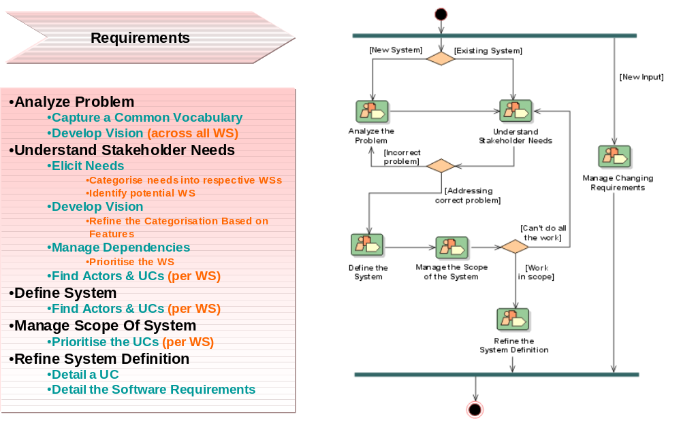
Source: IBM-Rational Software

Figure 3: Requirements Workflow

Workflow Detail: Analyze the Problem

Activity: Capture a Common Vocabulary
- Find Common Terms

Role
System Analyst

Artifact
The results should be recorded in Glossary.

Activity: Develop Vision (across all Web services)
- Gain agreement on the some problems faced
- Identify stakeholders of the Web services
- Define boundaries of Web services
- Identify (initial) constraints to be imposed on the Web services
- Formulate Problem Statement (positioning why the need to develop Web services)

Role
System Analyst

Artifact
The results should be recorded in Requirements Attributes and Vision.

Workflow Detail: Understand Stakeholder Needs

Activity: Elicit Needs
- Determine sources for requirements (who and where can you gather the requirements of Web services)
- Gather information (based on stakeholders identified)
- Conduct brainstorming session
- Categorise the needs into respective Web services
- Identify the Web services

Role
System Analyst

Artifact
The results should be recorded in Stakeholder Requests.

Activity: Develop Vision
- Gain agreement on the some problems faced
- Identify stakeholders of the Web services
- Refine boundaries of Web services
- Identify the new constraints (or refine on existing constraints)
- Formulate Problem Statement (positioning why the need to develop Web services)
- Define features of the Web services based on the needs list
- Refine the categorisation of the Web services based on the features

Role
System Analyst

Artifact
The results should be recorded in Requirements Attributes and Vision.

Activity: Manage Dependencies
- Assign attributes to the features of the Web services
- Prioritise the Web services
- Establish and verify traceability (what requirement types to be traced)
- Manage changing requirements

Role
System Analyst

Artifact
The results should be recorded in Requirements Attributes, Requirements Management Plan and Vision.

Activity: Find Actors and Use Cases (per Web service)
- Find Actors
- Find Use Cases
- Create use case model

Role
System Analyst

Artifact
The results should be recorded in Use Case Model and Supplementary Specifications.

Workflow Detail: Define the System

Activity: Find Actors and Use Cases (per Web service)
- Find Actors
- Find Use Cases
- Refine use case model to include outlined use cases

Role
System Analyst

Artifact
The results should be recorded in Use Case Model and Supplementary Specifications.

Workflow Detail: Manage the Scope of the System

Activity: Prioritise the Use Cases (per Web service)
- Prioritise Use Cases and Scenarios

Role
Software Architect

Artifact
The results should be recorded in Software Architecture Document and Software Requirement.

Workflow Detail: Refine the System Definition

Activity: Detail a Use Case
- Review and Refine the Scenarios
- Detail the Flow of Events
- Structure the Flow of Events
- Describe any Special Requirements

Role
Requirements Specifier

Artifact
The results should be recorded in Use Case Model, Supplementary Specifications.

Activity: Detail the Software Requirements
- Detail the Software Requirements
- Generate Supporting Reports (Use Case Model and Supplementary Specs)

Role
Requirements Specifier

Artifact
The results should be recorded in Software Requirement and Software Requirements Specifications.

Discipline: Analysis and Design

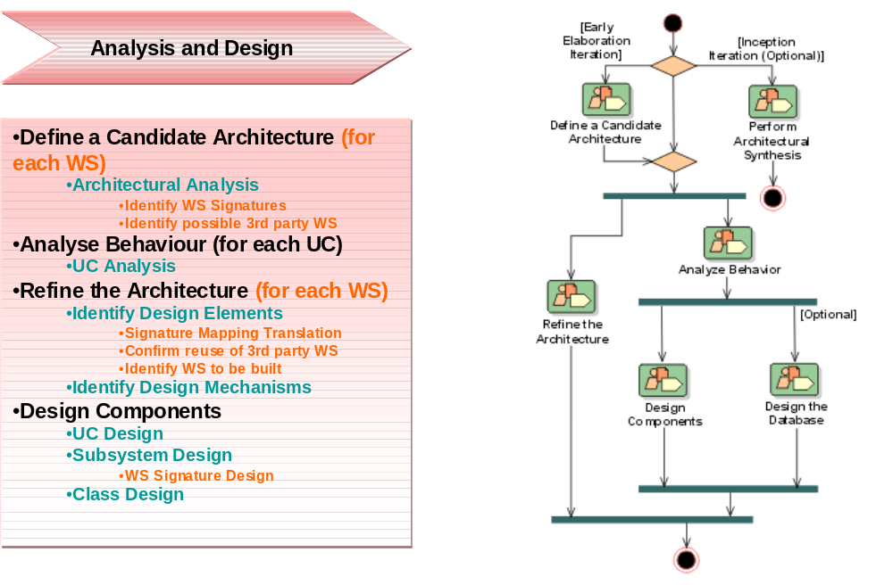
Source: IBM-Rational Software
Figure 4: Analysis and Design Workflow

Workflow Detail: Define a Candidate Architecture (for each Web service)

Activity: Architectural Analysis
- Define the high-level organization
- Identify key abstractions
- Identify analysis mechanisms
- Identify the use case realization for the current iteration
- Identify the Web Service signatures
- Identify the possible 3rd party Web Service reuse

Role
Software Architect

Artifact
The results should be recorded in Software Architecture Document and Design Model.

Workflow Detail: Analyse Behaviour (for each use case)

Activity: Use Case Analysis
- Find analysis classes from Use Case Behaviour
- Distribute behaviour to analysis classes
- Describe responsibilities
- Reconcile the use case realization
- Qualify analysis mechanisms

Role
Designer

Artifact
The results should be recorded in Analysis Model and Use Case Realization.

Workflow Detail: Refine the Architecture (for each Web service)

Activity: Identify Design Elements
- Signature mapping translation
- Confirm reuse of 3rd party Web Services
- Identify Web Services to be built
- Identify classes and subsystems based on the activity Use Case Analysis
- Identify subsystem interfaces
  - Identify candidate interfaces (from internal or external source)
  - Look for similarities between interfaces
- Identify reuse opportunities
  - Look for existing subsystems with similar interfaces
  - Modify the newly identified interfaces to improve the fit
- Update the organization of the design model

Role
Software Architect

Artifact
The results should be recorded in Design Model.

Activity: Identify Design Mechanisms
- Inventory the implementation mechanisms
- Map design mechanisms to implementation mechanisms
- Document architectural mechanisms (in terms of patterns)

Role
Software Architect

Artifact
The results should be recorded in Software Architecture Document and Design Model.

Workflow Detail: Design Components

Activity: Use Case Design
- Describe Interactions between design objects (refine interaction diagrams)
- Simplify sequence diagrams with interfaces of subsystems (if any subsystems found)
- Unify design classes and subsystems

Role
Designer

Artifact
The results should be recorded in Design Model and Use Case Realization.

Activity: Subsystem Design
- Interface realization (Web service signature design)
- Distribute subsystem behaviour to subsystem elements (design the Web service)
- Document subsystem elements (internal structure of the Web service)
- Describe subsystem dependencies

Role
Designer

Artifact
The results should be recorded in Design Model.

Activity: Class Design
- Create initial design classes
- Define class visibility
- Define operations
- Define attributes
- Define dependencies
- Define associations
- Define generalizations
- Handle non-function requirements

Role
Designer

Artifact
The results should be recorded in Design Model.

Discipline: Implementation

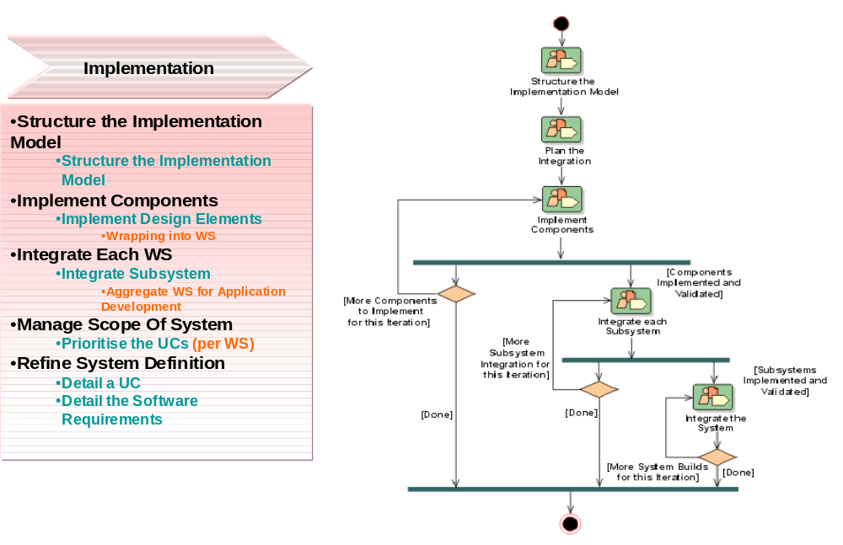
Source: IBM-Rational Software
Figure 5: Implementation Workflow

Workflow Detail: Structure the Implementation Model

Activity: Structure the Implementation Model
- Establish the implementation model structure
- Define imports for each implementation components
- Decide how to treat executables (and other derived objects)

Role
Software Architect

Artifact
The results should be recorded in Software Architecture Document and Implementation Model.

Workflow Detail: Implement Components

Activity: Implement Design Elements
- Implement operations
- Implement associations
- Implement attributes
- Provide feedback to design
- Wrapping into Web Service

Role
Implementer

Artifact
The results should be recorded in Implementation Element.

Workflow Detail: Integrate Each Web Service

Activity: Integrate Subsystem
- Integrate implementation elements
- Aggregate Web Service for application development

Role
Integrator

Artifact
The results should be recorded in Build and Implementation Model.

Workflow Detail: Manage the Scope of the System

Activity: Prioritise the Use Cases (per Web service)
- Prioritise Use Cases and Scenarios

Role
Software Architect

Artifact
The results should be recorded in Software Architecture Document and Software Requirement.

Workflow Detail: Refine the System Definition

Activity: Detail a Use Case
- Review and Refine the Scenarios
- Detail the Flow of Events
- Structure the Flow of Events
- Describe any Special Requirements

Role
Requirement Specifier

Artifact
The results should be recorded in Use Case Model and Supplementary Specifications.

Activity: Detail the Software Requirements
- Detail the Software Requirements
- Generate Supporting Reports (Use Case Model and Supplementary Specs)

Role
Requirement Specifier

Artifact
The results should be recorded in Software Requirement and Software Requirements Specifications.

Discipline: Testing

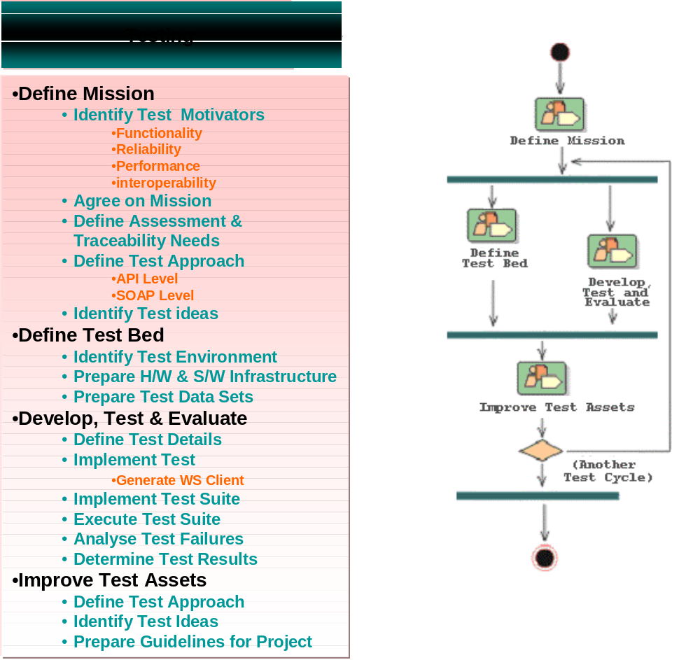
Source: IBM-Rational Software
Figure 6: Testing Workflow

Workflow Detail: Define Mission

Activity: Identify Test Motivators
- Identify iteration target items
  - Web services
  - configuration (deployment platform)
- Gather and examine related information
  - dependencies of services to be tested
    - other services
    - configuration (deployment platform)
- Identify candidate motivators
  - Web services
    - functionality
    - usability
    - reliability
    - performance
    - supportability
- Determine quality risks
  - prioritise the tests requirements
    - architecture significant
    - value of service
    - stability
  - define the acceptable quality level
- Define motivator list
  - define the specific Web services ready to be tested
- Maintain traceability relationships
  - manage the test requirements to the other requirements
    - impact analysis
- Evaluate and verify your results
  - verify with team members on the objectives of this activity

Role
Test Manager

Artifact
The results should be recorded in Test Plan.

Activity: Agree on the Mission
- Investigate options for the scope of the assessment effort
  - determine the resources needed to achieve the testing
  - scope the test based on existing resources
- Formulate mission statement
  - determine a balance between the need for:
    - Test for correctness
    - Test for completeness
  - determine Test Coverage
    - Code
    - Test requirements
    - Defect
    - Test Result
  - determine the necessary stages of testing
    - Unit (Formal/Informal)
    - Integration (Formal/Informal)
    - System (Formal)
    - UAT (Formal)
- Identify test deliverables
  - Test Plan (based on type of tests)
    - Test Cases (high-level)
      - Test Scenarios (test case)
        - Explanation
        - Deriving Test Cases from Use Cases
        - Deriving Test Cases from Supplementary Specifications
          - Deriving Test Cases for Performance Tests
          - Deriving Test Cases for Security / Access Tests
          - Deriving Test Cases for Configuration Tests
          - Deriving Test Cases for Installation Tests
          - Deriving Test Cases for other Non Functional Tests
        - Deriving Test Cases for Product Acceptance Tests
        - Build Verification Test Cases for Regression Tests
        - Defining Test Data for Test Cases
        - use the existing test ideas as a mean to identify possible scenarios
        - verify all extension points where not explicitly defined
          - Test Procedures/Steps
            - Test Scripts
    - Test Result
- Evaluate and verify your results
  - verify with team members and stakeholder on the objectives of this activity

Role
Test Manager

Artifact
The results should be recorded in Test Plan.

Activity: Define Assessment and Traceability Needs
- Identify assessment and traceability requirements
  - how to assess formal and informal testing
- Consider constraints
  - limitation that prohibits the testing effort
    - existing skills set
    - availability of resources
      - tools
      - information
      - process
      - skills set
- Consider possible strategies
  - acquire required skills
    - vendor
    - training
  - outsource
- Define and agree on the assessment strategy
  - define checkpoint to assess the strategy (verify test approach)
- Define tool requirements
  - Use existing tool
    - Good match
    - Workaround solution
    - Acquire new technology
  - Increase productivity
    - Regression testing
- Evaluate and verify your results
  - verify with team members and stakeholder on the objectives of this activity

Role
Test Analyst

Artifact
The results should be recorded in Test Plan.

Activity: Define Test Approach
- Examine test motivators and target test items
  - test requirements - FURPS
- Examine the software architecture
  - understand how the target is deployed
    - select the appropriate test point
- Consider the appropriate breadth and depth of the test approach
  - determine strategy for the test points
    - API level
    - SOAP Client level
      - Atomic / Collaboration
- Identify existing test techniques for reuse
  - gather experience from team members
    - identify the possible technique for use
      - select appropriate technique
      - the rest as contingency
- Define techniques
  - Outline each technique for each type of test
    - Automated/Manual/semi-automated
      - Require tool
    - Framework
      - Test Design
        - maintenance
        - effectiveness
        - reusable
        - longevity
      - Implementation tips and tricks
    - Test bed pre-condition/post-condition
      - Test data management
    - Test Result logging/reporting
- Define the test asset configuration management strategy
  - Identify possible test assets management
    - version control
    - backup
- Survey availability of reusable assets
  - Identify existing test asset which could be reused
    - Based on test design
- Evaluate and verify your results
  - verify with team members and stakeholder on the objectives of this activity

Role
Test Designer

Artifact
The results should be recorded in Test Environment Configuration, Test Plan and Test Strategy.

Activity: Identify Test Ideas
- Identify relevant Test Motivators and Target Test Items
  - Determine level of testing required for specific/partial targets
    - Correctness (must)
    - Completeness (vary)
      - The test ideas will help you to identify the possible test scenarios you would need to address based on the signature of each method call found in the specific Web service
- Examine relevant available Test-Idea Catalogs
  - Check existing best practices to test specific
- Brainstorm additional Test Ideas
  - Enhance Test Idea catalog
  - Examine Web service and analyse every method signature
    - Valid value
      - Boundary value
        - Identify possible values for each parameter. Valid and invalid
      - Special value
    - Invalid value
      - Must conform to the syntax of the parameter data structure
    - Guidelines: Test Ideas for Booleans and Boundaries
    - Guidelines: Test Ideas for Method Calls
- Refine the Test-Ideas List
  - update existing list
- Evaluate and verify your results
  - verify with team members and stakeholder on the objectives of this activity

Role
Test Analyst

Artifact
The results should be recorded in Test-Ideas List.

Workflow Detail: Define Test Bed

Activity: Identify Test Environment
- Identify the application architecture and deployment
  - Hardware and Software (20% effort)
    - Configurations
  - Test Data (80% effort)
    - Explanation
    - Depth
    - Breadth
    - Scope
    - Architecture
- Identify the test facilities
  - Tools
    - Hardware and Software requirements
  - Roles
    - Sys Admin, DBA, etc
  - Security

Role
Test Designer

Artifact
The results should be recorded in Test Environment Configuration.

Activity: Prepare H/W & S/W Infrastructure
- Select the appropriate technique to control environment
- Set up test environment
  - settings and configuration
- Restore test environment
  - Logs
  - Temp files
  - Software and Hardware settings

Role
Test System Administrator, DBA

Artifact
The results should be recorded in Test Environment Configuration.

Activity: Prepare Test Data Sets
- Identify the test data to be used
  - Depth
  - Breadth
  - Scope
- Identify the strategy to restore test data
  - data refresh
  - data re-initialize
  - data reset
  - data roll forward

Role
Test Analyst

Artifact
The results should be recorded in Test Data.

Workflow Detail: Develop, Test and Evaluate

Activity: Define Test Details
- Examine the Target Test Item and related Test-Ideas List
- Select a subset of the test ideas to detail
- For each test idea, design the Test;
  - identify input, output and execution conditions
  - identify candidate points of observation
  - identify candidate points of control
  - Identify appropriate oracles
- Define required data sources, values and ranges
- Source sufficient consumable Test Data
- Maintain traceability relationships
- Evaluate and verify your results

Role
Test Analyst

Artifact
The results should be recorded in Test Case, Test Data and Test Script.

Activity: Implement Test
- Test Design
  - Macro-Level
    - Collaboration of high-level test case
  - Micro-Level
    - Test script implementation level
      - Affected by the test data management
        - Data partitioning strategy
        - Data “life-cycle” strategy
- Select appropriate implementation technique
- Set up test environment preconditions
- Generate Web service client
- Implement the test
- Establish external data sets
- Verify the test implementation
- Restore test environment to known state
- Maintain traceability relationships
- Evaluate and verify your results

Role
Tester

Artifact
The results should be recorded in Test Script.

Activity: Implement Test Suite
- Examine candidate Test Suites
- Examine related Tests and Target Test Items
- Identify Test dependencies
- Identify opportunities for reuse
- Apply necessary infrastructure utilities
- Determine recovery requirements
- Implement recovery requirements
- Stabilize the Test Suite
- Maintain traceability relationships
- Evaluate and verify your results

Role
Tester

Artifact
The results should be recorded in Test Suite.

Activity: Execute Test Suite
- Setup test environment to known state
- Set execution tool options
- Schedule Test Suite execution
- Execute Test Suite
- Evaluate execution of Test Suite
- Recover from halted tests
- Inspect the Test Logs for completeness and accuracy
- Restore test environment to known state
- Maintain traceability relationships
- Evaluate and verify your results

Role
Tester

Artifact
The results should be recorded in Test Log.

Activity: Analyse Test Failures
- Examine the Test Logs
- Capture nontrivial incident data
- Identify procedural errors in the test
- Locate and isolate failures
- Diagnose failure symptoms and characteristics
- Identify candidate solutions
- Document you findings appropriately
- Evaluate and verify your results

Role
Tester

Artifact
The results should be recorded in Change Request.

Activity: Determine Test Results
- Examine all test incidents and failures
- Create and maintain Change Requests
- Analyze and evaluate status
- Make an assessment of the current quality experience
- Make an assessment of outstanding quality risks
- Make an assessment of test coverage
- Draft the Test Evaluation Summary
- Advise stakeholders of key findings
- Evaluate and verify your results

Role
Test Analyst

Artifact
The results should be recorded in Test Evaluation Summary and Test Results.

Workflow Detail: Improve Test Assets

Activity: Define Test Approach (Refinement)
- As in “Define Test Approach” activity found in “Define Mission” Workflow

Role
Test Designer

Artifact
The results should be recorded in Test Environment Configuration, Test Plan and Test Strategy.

Activity: Identify Test Ideas (Refinement)
- As in “Identify Test Ideas” activity found in “Define Mission” Workflow

Role
Test Analyst

Artifact
The results should be recorded in Test-Ideas List.

Activity: Prepare Guidelines for the Project
- Identify the Project's Needs for Guidelines
- Prepare Guidelines for Project Use
- Maintain Guidelines

Role
Process Engineer

Artifact
The results should be recorded in Project Specific Guidelines.

Discipline: Deployment
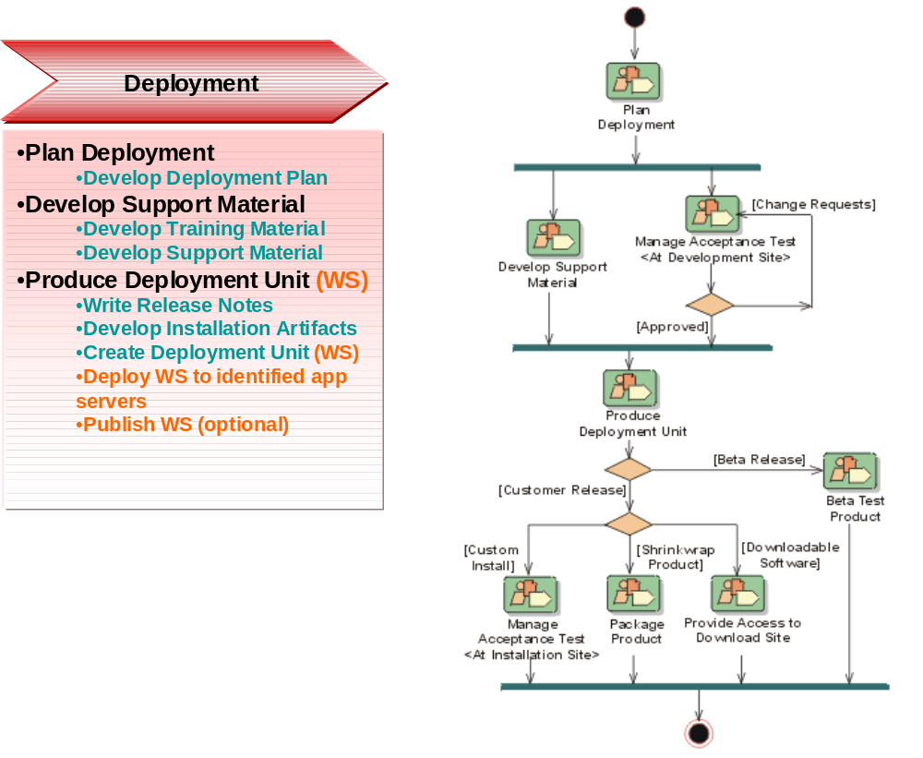
Source: IBM-Rational Software
Figure 7: Deployment Workflow

Workflow Detail: Plan Deployment

Activity: Develop Deployment Plan
- Plan how to produce the software
- Plan how to package the software
- Plan how to distribute the software
- Plan how to install the software
- Migration
- Providing help and assistance to the users

Role
Deployment Manager

Artifact
The results should be recorded in Deployment Plan.

Workflow Detail: Develop Support Material

Activity: Develop Training Material
- Develop an outline for the training materials
- Write the training materials

Role
Course Developer

Artifact
The results should be recorded in Training Materials.

Activity: Develop Support Material
- Develop end-user support material

Role
Technical Writer

Artifact
The results should be recorded in End-User Support Material.

Workflow Detail: Produce Deployment Unit (Web service)

Activity: Write Release Notes
- Describe the major new features and changes in the release
- Describe any known bugs and limitations or workarounds to using the product

Role
Deployment Manager

Artifact
The results should be recorded in Release Notes.

Activity: Develop Installation Artifacts
- Produce all the software required to install and uninstall the product quickly, easily and safely without affecting other applications or system characteristics

Role
Implementer

Artifact
The results should be recorded in Installation Artifacts.

Activity: Create Deployment Unit (Web service)
- Create a deployment unit that is sufficiently complete to be downloadable, installable and run on a node as a group
- A deployment unit consists of a build (an executable collection of components), documents (end-user support material and release notes) and installation artifacts

Role
Configuration Manager

Artifact
The results should be recorded in Deployment Unit.

Activity: Deploy Web Service to identified app servers
- Identify the service end-point
- Create the deployment script and configure the deployment parameters
- Deploy the Web service
- Generate the WSDL

Role
Implementer

Artifact
The results should be recorded in Installation Artifacts.

Activity: Publish Web service [optional]
- Identify the UDDI registry
- Prepare the information needed for publishing
- Publish the Web service in the UDDI registry
- Perform a find and bind to test

Role
Implementer

Artifact
The results should be recorded in Installation Artifacts.

References

Normative

Non-Normative
- “Rational Unified Process”, Version 2003.06.00.65, IBM-Rational Software.

- “Rational Unified Process for Developing Web Services”, Version 1.0, Java Smart Services Laboratory and Rational Software Pte. Ltd., Aug 2003.
- Acknowledgments
The following individuals were members of the committee during the development of this documentation:
- Ravi Shankar, CrimsonLogic Pte. Ltd.
- Jagdip Talla, CrimsonLogic Pte. Ltd.
- Andy Tan, Individual
- Roberto Pascual, IDA

- Revision History
Rev | Date | By Whom | What
wd-01 | 2004-09-30 | Lai Peng CHAN  Chai Hong ANG | Initial version
 | 2004-12-23 | Chai Hong ANG | Split the original document into two

- Notices
OASIS takes no position regarding the validity or scope of any intellectual property or other rights that might be claimed to pertain to the implementation or use of the technology described in this document or the extent to which any license under such rights might or might not be available; neither does it represent that it has made any effort to identify any such rights. Information on OASIS's procedures with respect to rights in OASIS specifications can be found at the OASIS website. Copies of claims of rights made available for publication and any assurances of licenses to be made available, or the result of an attempt made to obtain a general license or permission for the use of such proprietary rights by implementors or users of this specification, can be obtained from the OASIS Executive Director.
OASIS invites any interested party to bring to its attention any copyrights, patents or patent applications, or other proprietary rights which may cover technology that may be required to implement this specification. Please address the information to the OASIS Executive Director.
Copyright © OASIS Open 2004. All Rights Reserved.
This document and translations of it may be copied and furnished to others, and derivative works that comment on or otherwise explain it or assist in its implementation may be prepared, copied, published and distributed, in whole or in part, without restriction of any kind, provided that the above copyright notice and this paragraph are included on all such copies and derivative works. However, this document itself does not be modified in any way, such as by removing the copyright notice or references to OASIS, except as needed for the purpose of developing OASIS specifications, in which case the procedures for copyrights defined in the OASIS Intellectual Property Rights document must be followed, or as required to translate it into languages other than English.
The limited permissions granted above are perpetual and will not be revoked by OASIS or its successors or assigns.
This document and the information contained herein is provided on an “AS IS” basis and OASIS DISCLAIMS ALL WARRANTIES, EXPRESS OR IMPLIED, INCLUDING BUT NOT LIMITED TO ANY WARRANTY THAT THE USE OF THE INFORMATION HEREIN WILL NOT INFRINGE ANY RIGHTS OR ANY IMPLIED WARRANTIES OF MERCHANTABILITY OR FITNESS FOR A PARTICULAR PURPOSE.

The activities in italics represent refinement of an activity previously defined.

